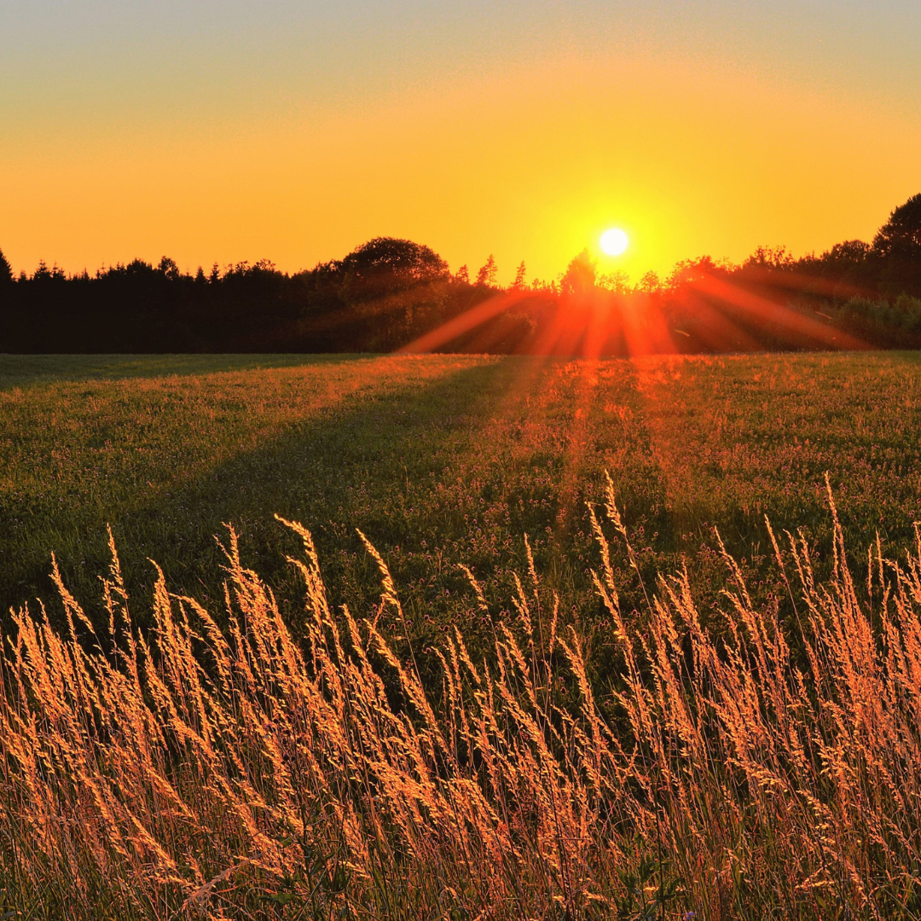



**C I T Y O F M E R C E D**

R EQ U EST F O R PROPOSALS

Open Call for Photographers

RFP Released: 03.04.2024 Deadline for Submittals: 04.30.2024

**M E R C E D C A 9 5 3 4 0**

**TABLE OF CONTENTS**

About the City of Merced 2

About Merced’s Arts & Culture Advisory Commission. 2

1. Project Description 3
2. Selection Process 3
3. Evaluation Criteria 3
4. Submission Requirements 4
5. Submitting Qualifications & Inquiry Contact 4
6. Proposed Timeline for the Project 5
7. Stipend Information 5

# 

# ABOUT THE CITY OF MERCED

Merced is a dynamic community of over 90,000 people, with a friendly small-town living in a mid-size city. The University of California Merced campus, opened in 2005, provides educational and economic opportunities, adding to the already-established growth of the region. As a result, Merced’s population is youthful and diverse. Located in the heart of California’s agricultural Central Valley, Merced is the region’s hub for education, culture, and business. The community offers pleasant neighborhoods, and tree-lined streets. Bicycle paths along creeks link major City parks. Even with recent increases in prices, Merced’s housing remains affordable compared to many other California locations. In addition, Merced’s revitalized downtown is emerging as the entertainment center of the area. Annual events and festivals bring regional and even national recognition.

The City’s amenities include the Applegate Zoo, Art Kamangar Center at the Merced Theatre, the Mainzer Theatre and Restaurant, the Merced Multicultural Arts Center, Playhouse Merced, the Senior Community Center, the Historic Tioga Apartments, Merced College, University of California at Merced, a wide array of restaurants, various sports facilities, Lake Yosemite, plentiful public transportations, and more.

# ABOUT MERCED’S ARTS & CULTURE ADVISORY COMMISSION

The Arts and Culture Advisory Commission (ACAC) was established in 2018 to advise the City Council on matters about public art, art projects, cultural programs, and activities, and the promotion of art within the City of Merced (M.M.C. section 2.54.010). The ACAC’s mission is to encourage and promote programs and events that enhance the art and cultural development in Merced while engaging community members and local businesses; promote the role of art and culture in contributing to the beautification and quality of life in Merced; recognize art and cultural events and activities that enhance vitality and innovation in Merced; promote inclusion of artistic endeavors and cultural activities reflective of the Merced community; and preserve the community’s artistic works and cultural identities.

# PROJECT DESCRIPTION

The City of Merced is seeking proposals from local photographers interested in showcasing their original photographs of a sunrise or a sunset captured within Merced city limits at an exhibition on June 8, 2024, at the Applegate Park MOAT. Professional photography experience is not required. This initiative aims to provide a platform for local photographers, both aspiring and seasoned, to gain exposure and for the community to appreciate their talent. Hosting the photography event at the Applegate Park MOAT aligns with the City’s commitment to cultural enrichment and supporting local talent.

**The application submittal deadline is 5 pm (PST) Tuesday, April 30, 2024.**

# 

# SELECTION PROCESS

Interested photographers are invited to submit their proposals featuring a high-quality electronic image of a sunrise or sunset within Merced city limits. The image should be accompanied by a brief photographer bio and photograph description including location, time, and any other pertinent details. Submissions will be reviewed by a subcommittee. The subcommittee will select 15 photographs based on a scoring metric outlined in this RFP. Selected photographers will receive a stipend as reimbursement for enlarging and mounting their respective photograph to a high-quality 16x20 photograph for display at an exhibition to be held at the Applegate Park MOAT on June 8, 2024. Remaining qualified submissions will be displayed as a 4x6 photograph in a collage during the exhibition.

# EVALUATION CRITERIA

Selection Criteria. The Selection Panel shall use the following criteria to select a photographer and photograph:

* + Photograph must be the original work of the photographer.
  + Originality and creativity of the photograph
  + Relevance to the theme of a sunrise or a sunset within Merced city limits.
  + Clarity and composition of the original high-quality electronic image
  + Additional information about submitting a high-quality electronic image:
    - 1200px max on the long side of the image digital file. It can be easily printed as a 4x6 photograph.
    - 6MB max file size in JPG format.
  + Completeness and accuracy of accompany descriptions.
  + Photographer’s ability to create an original high-quality 16 x 20 photograph for display at the exhibition.
  + Agreement to display the photograph at the event.

# SUBMISSION REQUIREMENTS

Interested photographers must submit the following information in the order listed:

1. Cover sheet with name, phone number, and email address.
2. Brief biography. Tell us briefly who you are, explain your inspiration and motivation for your photography and why you are submitting your photograph for consideration.
3. A high-quality electronic image that can be easily printed as a 4x6 photograph.
4. Brief description including the location, date, time, and other pertinent details.

# INQUIRY CONTACT & SUBMITTING QUALIFICATIONS

Direct all inquiries to Senior Management Analyst/Public Information Officer, Jennifer Flachman via email, by 5 pm, Tuesday, April 30, 2024.

**APPLICATION PACKAGES ARE DUE BY 5 PM (PST) ON TUESDAY, APRIL 30, 2024.**

**Address proposals to:**

**Senior Management Analyst/Public Information Officer, Jennifer Flachman**

**City of Merced / Office of the City Manager 678 W. 18th Street**

**Merced, CA 95340**

**Proposals are accepted via e-mail if received by the deadline.** *Proposals will not be accepted via postmarked mail, and fax.*

# PROPOSED TIMELINE FOR THE OPEN CALL FOR ART PROJECTS

**03/04/2024 – 04/30/2024 – Post RFP on City Website:**

* + Allow 58 days for qualifications to be received
  + Qualifications will be initially screened to ensure minimum requirements are met

**04/30/2024 through 05/10/2024 – Selection Panel Rates Proposals:**

* + Review Independently and Score
  + Scores compiled for May ACAC Meeting

**05/16/2024 – ACAC Meeting:**

* + Selection Panel makes recommendation to ACAC

**05/17/2024 – Photographer Notification**

* + 15 photographers be notified by email and will receive instructions to enlarge their high-quality electronically submitted photograph to a high-quality 16x20 photo affixed directly to a white or black mounting board. Self-adhesive mounting boards are preferable. Selected photos will be displayed on easels.
  + Remaining photos will be displayed during the June 8th exhibition.

**05/31/2024 – Photographer submissions due**

* + Photographers must submit their high-quality 16 x20 photo affixed directly to a white or black mounting board to be included in the 6/8/2024 exhibition.

**06/8/2024 – Exhibition at the MOAT**

* + The community is invited to a free exhibition event at the MOAT. Invitations and event advertising will be posted on the city’s website and social media platforms.

# PHOTOGRAPHER STIPEND

Fifteen (15) selected photographers will receive a $150 stipend as reimbursement for photo production and mounting for display.